

**VIRGINIA COMMONWEALTH UNIVERSITY**

**Statistical analysis and modelling (SCMA 632)**

**A2: Perform Multiple regression analysis and carry out the regression diagnostics**

**Lakshmy Cherussery Jayaprakash**

**V01110023**

**Date of Submission: 23-06-2024**

**CONTENTS**

|  |  |  |
| --- | --- | --- |
| **Sl. No.** | **Title** | **Page No.** |
| **1.** | Introduction | **1** |
| **2.** | Objective | **2** |
| **3.** | Business Significance | **3** |
| **4.** | Results and Interpretations  1-IPL  2-NSSO | **4-8** |
| **5.** | Codes:  1a- IPL Python  1b-IPL R  2a-NSSO Python  2b-NSSO R | **9-16** |
| **6.** | Recommendations | **17** |

**Introduction**

Regression analysis is a fundamental technique in predictive analytics used to understand the relationship between variables and make predictions based on data. It involves fitting a model that describes how the dependent variable changes as the independent variables vary. This method is widely used across various fields, from economics and finance to sports analytics and social sciences.

**Objective**

1. Analyze the relationship between IPL player performance (e.g., runs scored, wickets taken) and the salary they receive.

Conduct regression analysis to quantify how performance metrics impact player salaries.

1. Perform multiple regression analysis on the "NSSO68.csv" dataset to understand the factors influencing food expenditure (MPCE_MRP) in Gujarat.

Conduct regression diagnostics to ensure the model meets assumptions and interpret the findings.

**Business Significace**

Insights from this analysis can inform policy decisions related to welfare programs and economic policies aimed at improving food security and consumption patterns.

This analysis can help policymakers, researchers, and businesses make informed decisions related to welfare programs, economic policies, and market strategies targeted at improving food security and consumption patterns.

Understanding how player performance correlates with salary in the IPL is crucial for team management, player negotiations, and franchise strategies. This analysis helps teams identify which performance metrics are most valuable in terms of return on investment (ROI) and player salary decisions.

**Results and Interpretations**

**1a- IPL- Python**

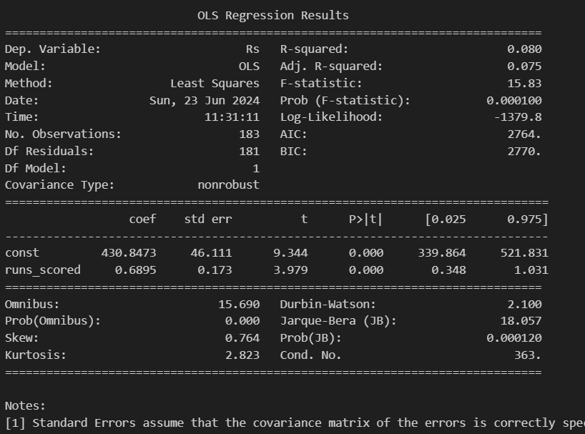

Interpretation:

Ihe regression results indicate that runs_scored is a significant predictor of Rs, but it explains only a small portion of the variance in Rs (8%). The model is statistically significant, but the low R-squared value suggests that other factors might also be influencing Rs that are not included in the model. Additionally, the diagnostic tests suggest that there might be some issues with the normality of the residuals.

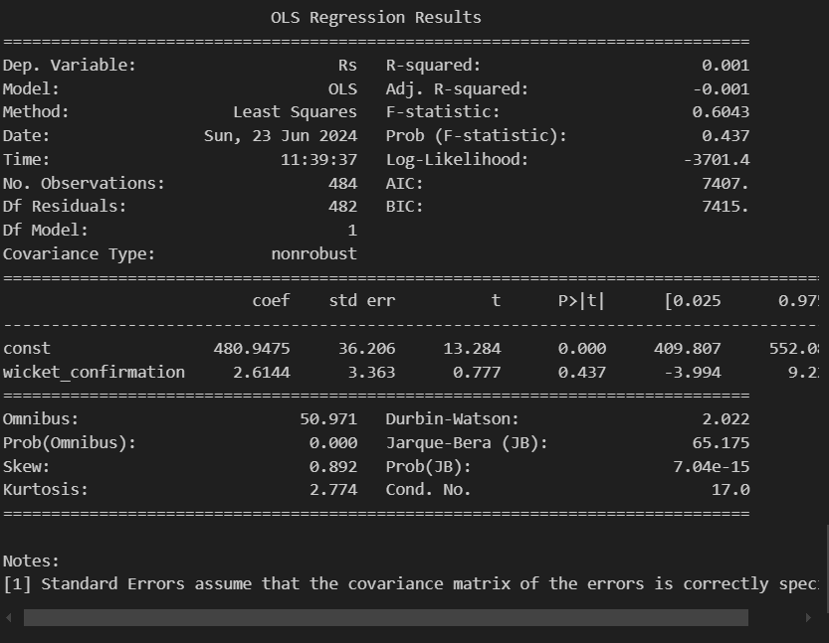

Interpretation:

The regression results indicate that wicket_confirmation is not a significant predictor of Rs. The extremely low R-squared value (0.1%) suggests that wicket_confirmation explains almost none of the variance in Rs. The model as a whole is not statistically significant (Prob F-statistic is 0.437), and the p-value for the slope coefficient of wicket_confirmation (0.437) indicates that it is not a significant predictor. Additionally, the diagnostic tests suggest potential issues with the normality of the residuals.

**1b- IPL- R**

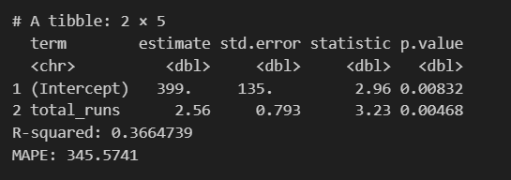

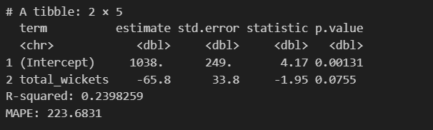

**2a- NSSO Python**

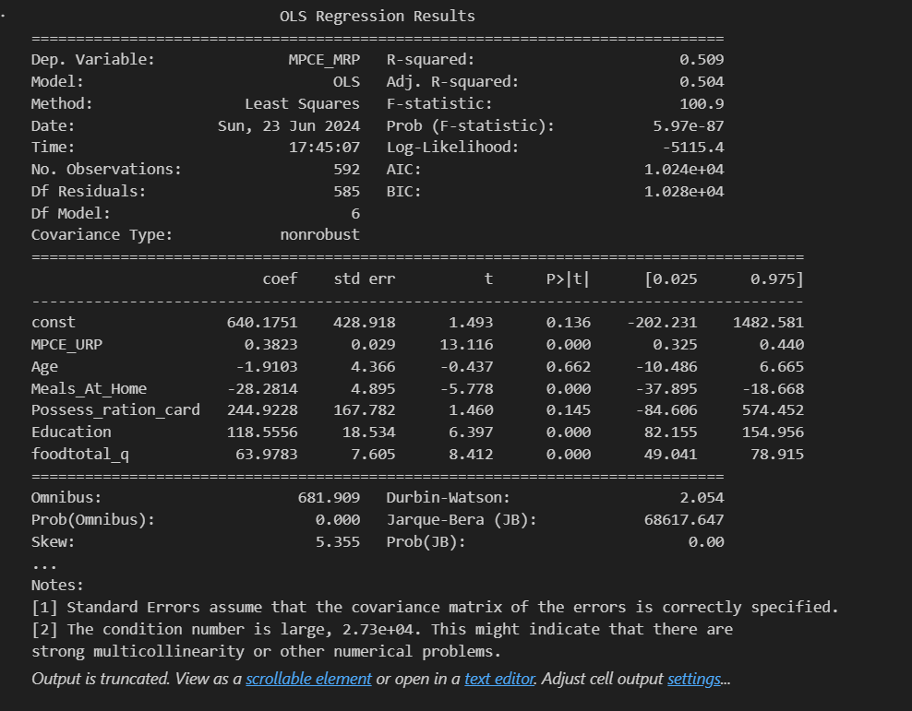

Interpretations:

**Significant Variables**: MPCE_URP, Meals_At_Home, Education, and foodtotal_q appear to be statistically significant predictors of MPCE_MRP, as indicated by their low p-values (< 0.05).  
**Model Fit**: The model overall is statistically significant (Prob F-statistic is very low), indicating that at least some of the independent variables are helpful in predicting MPCE_MRP.

**R-squared**: The model explains approximately 50.9% of the variability in MPCE_MRP, which suggests that the included variables collectively have a moderate explanatory power.

**Diagnostic Tests**: There are indications of potential issues with the normality of residuals and the presence of multicollinearity (high condition number), which should be further investigated or addressed if necessary.

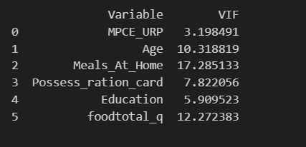

Interpretations:

**Multicollinearity**: VIF values above 10 indicate problematic levels of multicollinearity, potentially leading to unreliable coefficient estimates and reduced interpretability of the model.



Interpretations:

The equation provided is the regression equation derived from OLS (Ordinary Least Squares) regression model.

Intercept (Constant): 640.18

**2b- R prgm**

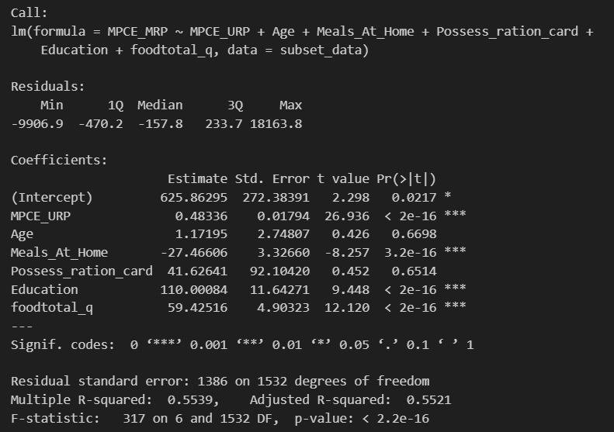

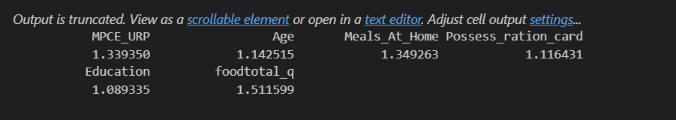

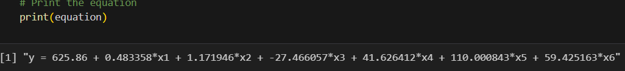

**Codes**

**1a- IPL Python**

import pandas as pd, numpy as np

import os

os.chdir('E:\Assignments_SCMA632\Data')

df_ipl = pd.read_csv("IPL_ball_by_ball_updated till 2024.csv",low_memory=False)

salary = pd.read_excel("IPL SALARIES 2024.xlsx")

df_ipl.columns

grouped_data = df_ipl.groupby(['Season', 'Innings No', 'Striker','Bowler']).agg({'runs_scored': sum, 'wicket_confirmation':sum}).reset_index()

grouped_data

total_runs_each_year = grouped_data.groupby(['Season', 'Striker'])['runs_scored'].sum().reset_index()

total_wicket_each_year = grouped_data.groupby(['Season', 'Bowler'])['wicket_confirmation'].sum().reset_index()

total_runs_each_year

#pip install python-Levenshtein

# Convert to DataFrame

df_salary = salary.copy()

df_runs = total_runs_each_year.copy()

# Function to match names

def match_names(name, names_list):

    match, score = process.extractOne(name, names_list)

    return match if score >= 80 else None  # Use a threshold score of 80

# Create a new column in df_salary with matched names from df_runs

df_salary['Matched_Player'] = df_salary['Player'].apply(lambda x: match_names(x, df_runs['Striker'].tolist()))

# Merge the DataFrames on the matched names

df_merged = pd.merge(df_salary, df_runs, left_on='Matched_Player', right_on='Striker')

df_original = df_merged.copy()

#susbsets data for last three years

df_merged = df_merged.loc[df_merged['Season'].isin(['2021', '2022', '2023'])]

df_merged.Season.unique()

df_merged.head()

from sklearn.linear_model import LinearRegression

from sklearn.model_selection import train_test_split

from sklearn.metrics import mean_squared_error

import pandas as pd

from sklearn.linear_model import LinearRegression

from sklearn.metrics import r2_score, mean_absolute_percentage_error

X = df_merged[['runs_scored']] # Independent variable(s)

y = df_merged['Rs'] # Dependent variable

# Split the data into training and test sets (80% for training, 20% for testing)

X_train, X_test, y_train, y_test = train_test_split(X, y, test_size=0.2, random_state=42)

# Create a LinearRegression model

model = LinearRegression()

# Fit the model on the training data

model.fit(X_train, y_train)

X.head()

import pandas as pd

from sklearn.model_selection import train_test_split

import statsmodels.api as sm

# Assuming df_merged is already defined and contains the necessary columns

X = df_merged[['runs_scored']] # Independent variable(s)

y = df_merged['Rs'] # Dependent variable

# Split the data into training and test sets (80% for training, 20% for testing)

X_train, X_test, y_train, y_test = train_test_split(X, y, test_size=0.2, random_state=42)

# Add a constant to the model (intercept)

X_train_sm = sm.add_constant(X_train)

# Create a statsmodels OLS regression model

model = sm.OLS(y_train, X_train_sm).fit()

# Get the summary of the model

summary = model.summary()

print(summary)

from fuzzywuzzy import process

# Convert to DataFrame

df_salary = salary.copy()

df_runs = total_wicket_each_year.copy()

# Function to match names

def match_names(name, names_list):

    match, score = process.extractOne(name, names_list)

    return match if score >= 80 else None  # Use a threshold score of 80

# Create a new column in df_salary with matched names from df_runs

df_salary['Matched_Player'] = df_salary['Player'].apply(lambda x: match_names(x, df_runs['Bowler'].tolist()))

# Merge the DataFrames on the matched names

df_merged = pd.merge(df_salary, df_runs, left_on='Matched_Player', right_on='Bowler')

df_merged[df_merged['wicket_confirmation']>10]

#susbsets data for last three years

df_merged = df_merged.loc[df_merged['Season'].isin(['2022'])]

import pandas as pd

from sklearn.model_selection import train_test_split

import statsmodels.api as sm

# Assuming df_merged is already defined and contains the necessary columns

X = df_merged[['wicket_confirmation']] # Independent variable(s)

y = df_merged['Rs'] # Dependent variable

# Split the data into training and test sets (80% for training, 20% for testing)

X_train, X_test, y_train, y_test = train_test_split(X, y, test_size=0.2, random_state=42)

# Add a constant to the model (intercept)

X_train_sm = sm.add_constant(X_train)

# Create a statsmodels OLS regression model

model = sm.OLS(y_train, X_train_sm).fit()

# Get the summary of the model

summary = model.summary()

print(summary)

**1b- IPL R prgm**

library(readxl)

library(dplyr)

df_ipl=read.csv("/content/IPL_ball_by_ball_updated till 2024 (1).csv")

salary =read_excel("IPL SALARIES 2024.xlsx")

head(df_ipl)

colnames(df_ipl)

# Grouping and Summarizing the Data

grouped_data <- df_ipl %>%

  group_by(Season, Innings.No, Striker, Bowler) %>%

  summarise(

    runs_scored = sum(runs_scored, na.rm = TRUE),

    wicket_confirmation = sum(wicket_confirmation, na.rm = TRUE)

  ) %>%

  ungroup()

grouped_data

# Calculate total runs each year

total_runs_each_year <- grouped_data %>%

  group_by(Season, Striker) %>%

  summarise(total_runs = sum(runs_scored, na.rm = TRUE)) %>%

  ungroup()

#calculate total wickets each year

total_wicket_each_year <- grouped_data %>%

  group_by(Season, Bowler) %>%

  summarise(total_wickets = sum(wicket_confirmation, na.rm = TRUE)) %>%

  ungroup()

total_runs_each_year

total_wicket_each_year

install.packages("stringdist")

# Function to match names using stringdist package

match_names <- function(name, names_list) {

  dist <- stringdist::stringdist(name, names_list, method = "jw")

  match <- names_list[which.min(dist)]

  score <- 1 - min(dist)

  return(ifelse(score >= 0.8, match, NA)) # Use a threshold score of 0.8

}

# Apply fuzzy matching to match names

salary$Matched_Player <- sapply(salary$Player, match_names, names_list = total_runs_each_year$Striker)

# Merge the DataFrames on the matched names

df_merged <- merge(salary, total_runs_each_year, by.x = "Matched_Player", by.y = "Striker")

# Subset data for the last three years

df_merged <- df_merged %>%

  filter(Season %in% c("2021", "2022", "2023"))

# Check the unique seasons

unique(df_merged$Season)

print(colnames(df_merged))

# Independent and dependent variables

X <- df_merged$total_runs

y <- df_merged$Rs

# Split the data into training and test sets (80% for training, 20% for testing)

set.seed(42)

train_indices <- sample(seq_len(nrow(df_merged)), size = 0.8 * nrow(df_merged))

train_data <- df_merged[train_indices, ]

test_data <- df_merged[-train_indices, ]

# OLS regression model

model <- lm(Rs ~ total_runs, data = train_data)

# Summary of the regression model

summary(model)

# Using the broom package to get tidy output

tidy_model <- broom::tidy(model)

print(tidy_model)

# Predicting on the test set

predictions <- predict(model, newdata = test_data)

# Calculate R-squared and Mean Absolute Percentage Error

r_squared <- summary(model)$r.squared

mape <- mean(abs((test_data$Rs - predictions) / test_data$Rs)) * 100

# Print metrics

cat("R-squared:", r_squared, "\n")

cat("MAPE:", mape, "\n")

# Apply fuzzy matching to match names for wickets

salary$Matched_Player <- sapply(salary$Player, match_names, names_list =total_wicket_each_year$Bowler)

# Merge the DataFrames on the matched names

df_merged <- merge(salary,total_wicket_each_year, by.x = "Matched_Player", by.y = "Bowler")

# Independent and dependent variables in wickets

X <- df_merged$total_wickets

y <- df_merged$Rs

# Split the data into training and test sets (80% for training, 20% for testing)

set.seed(42)

train_indices <- sample(seq_len(nrow(df_merged)), size = 0.8 * nrow(df_merged))

train_data <- df_merged[train_indices, ]

test_data <- df_merged[-train_indices, ]

# OLS regression model

model <- lm(Rs ~ total_wickets, data = train_data)

# Summary of the regression model

summary(model)

# Using the broom package to get tidy output

tidy_model <- broom::tidy(model)

print(tidy_model)

# Predicting on the test set

predictions <- predict(model, newdata = test_data)

# Calculate R-squared and Mean Absolute Percentage Error

r_squared <- summary(model)$r.squared

mape <- mean(abs((test_data$Rs - predictions) / test_data$Rs)) * 100

# Print metrics

cat("R-squared:", r_squared, "\n")

cat("MAPE:", mape, "\n")

**2a-NSSO Python**

import pandas as pd

import numpy as np

import statsmodels.api as sm

import statsmodels.formula.api as smf

import matplotlib.pyplot as plt

import seaborn as sns

from sklearn.model_selection import train_test_split

from sklearn.metrics import mean_squared_error

data = pd.read_csv("/content/NSSO68.csv")

#subset daa for GUJ

subset_data = data[data['state_1'] == 'GUJ'][['foodtotal_q', 'MPCE_MRP', 'MPCE_URP', 'Age', 'Meals_At_Home', 'Possess_ration_card', 'Education', 'No_of_Meals_per_day']]

print(subset_data.head())

# Check for missing values

print(subset_data.isnull().sum())

# Drop rows with any missing values

subset_data.dropna(inplace=True)

# Define the independent variables (X) and dependent variable (y)

X = subset_data[['MPCE_URP', 'Age', 'Meals_At_Home', 'Possess_ration_card', 'Education', 'foodtotal_q']]

y = subset_data['MPCE_MRP']

# Add constant to the features

X = sm.add_constant(X)

# Split data into training and test sets (80% training, 20% testing)

X_train, X_test, y_train, y_test = train_test_split(X, y, test_size=0.2, random_state=42)

# Fit the OLS model

model = sm.OLS(y_train, X_train).fit()

# Print model summary

print(model.summary())

# Check for multicollinearity using VIF

def calculate_vif(X):

    vif = pd.DataFrame()

    vif["Variable"] = X.columns

    vif["VIF"] = [variance_inflation_factor(X.values, i) for i in range(X.shape[1])]

    return vif

# ipython-input-13-7d005dd0a72d

!pip install statsmodels

import statsmodels.api as sm

from statsmodels.stats.outliers_influence import variance_inflation_factor

# Check for multicollinearity using VIF

def calculate_vif(X):

    vif = pd.DataFrame()

    vif["Variable"] = X.columns

    vif["VIF"] = [variance_inflation_factor(X.values, i) for i in range(X.shape[1])]

    return vif

# Calculate VIF for independent variables

vif_data = X_train.drop(columns=['const'])  # Exclude the constant column

vif_scores = calculate_vif(vif_data)

print(vif_scores)

# Extract coefficients from the model

coefficients = model.params

# Construct the equation

equation = "y = {:.2f}".format(coefficients['const'])

for i in range(1, len(coefficients)):

    equation += " + {:.6f}*{}".format(coefficients[i], X_train.columns[i])

# Print the equation

print(equation)

**2b-NSSO R prgm**

data=read.csv("/content/NSSO68.csv")

library(dplyr)

unique(data$state_1)

# Subset data to state Gujarat

subset_data <- data %>%

  filter(state_1 == 'GUJ') %>%

  select(foodtotal_q, MPCE_MRP, MPCE_URP,Age,Meals_At_Home,Possess_ration_card,Education, No_of_Meals_per_day)

print(subset_data)

sum(is.na(subset_data$MPCE_MRP))

sum(is.na(subset_data$MPCE_URP))

sum(is.na(subset_data$Age))

sum(is.na(subset_data$Possess_ration_card))

sum(is.na(data$Education))

impute_with_mean <- function(data, columns) {

  data %>%

    mutate(across(all_of(columns), ~ ifelse(is.na(.), mean(., na.rm = TRUE), .)))

}

# Columns to impute

columns_to_impute <- c("Education")

# Impute missing values with mean

data <- impute_with_mean(data, columns_to_impute)

sum(is.na(data$Education))

# Fit the regression model

model <- lm(MPCE_MRP ~ MPCE_URP + Age + Meals_At_Home + Possess_ration_card + Education + foodtotal_q, data = subset_data)

summary(model)

install.packages("car")

library(car)

# Check for multicollinearity using Variance Inflation Factor (VIF)

vif(model) # VIF Value more than 8 its problematic

# Extract the coefficients from the model

coefficients <- coef(model)

# Construct the equation

equation <- paste0("y = ", round(coefficients[1], 2))

for (i in 2:length(coefficients)) {

  equation <- paste0(equation, " + ", round(coefficients[i], 6), "*x", i-1)

}

# Print the equation

print(equation)

print(head(subset_data$MPCE_MRP,1))

print(head(subset_data$MPCE_URP,1))

print(head(subset_data$Age,1))

print(head(subset_data$Meals_At_Home,1))

print(head(subset_data$Possess_ration_card,1))

print(head(subset_data$Education,1))

print(head(subset_data$foodtotal_q,1))

**Recommendations**

Both datasets highlight the importance of including a comprehensive set of variables to understand the factors influencing salaries (in the case of IPL) and expenditure (in the case of NSSO-Gujarat). Addressing multicollinearity, incorporating additional relevant variables, and conducting further research are essential steps for improving the accuracy and applicability of the models. These insights can guide effective policy interventions and decision-making processes.